Name: ……………………………………………….. ( ) Class: ……… Date: …………………..

|  |  |  |
| --- | --- | --- |
| **2.1** | **Computer Architecture** | **Basic Hardware Components** |

1. A computer will consist of several key components.

The diagram below shows the insides of a desktop computer. Label each part below.

|  |  |  |  |  |
| --- | --- | --- | --- | --- |
| **data and address buses** | **processor** | **external drive** | **ports for input / output** | **memory** |

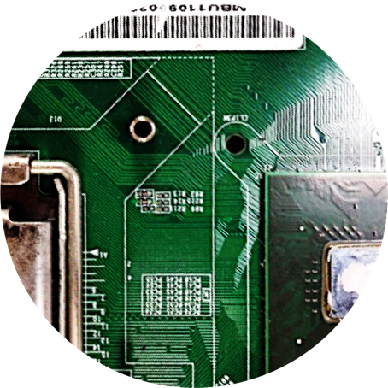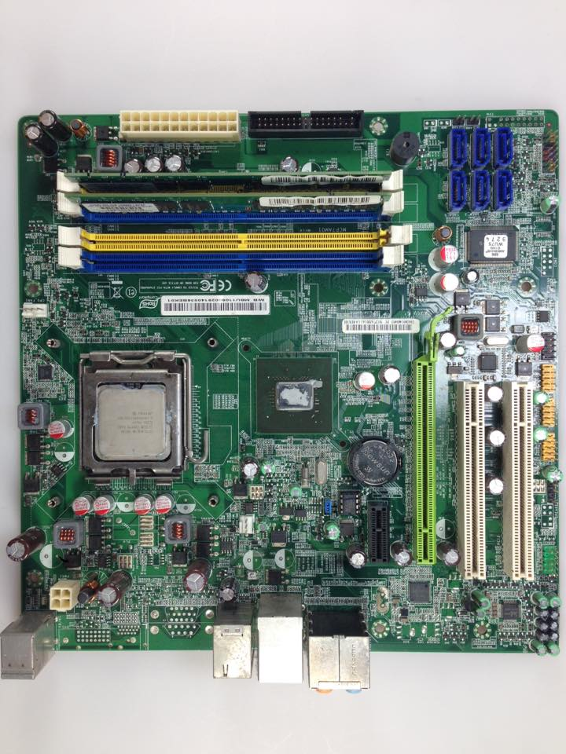

b)

a)

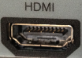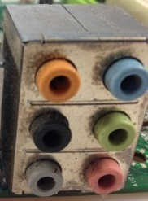

c)

**(lines on motherboard)**

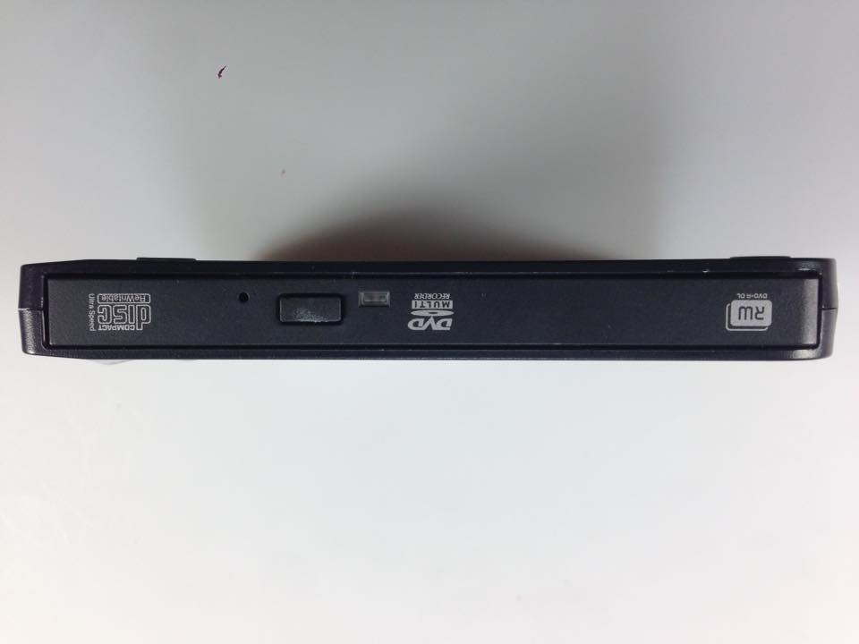

3.d)

e)

1. The two main functions of a processor are carried out by the arithmetic logic unit (ALU) and control unit. Describe the functions of ALU and control unit.

ALU ……………………………………………………………………………………………………………………………………………….

………………………………………………………………………………………………………………………………………………………

………………………………………………………………………………………………………………………………………………………

Control unit ………………………………………………………………………………………………………………………………….

………………………………………………………………………………………………………………………………………………………

………………………………………………………………………………………………………………………………………………………

1. The computer's memory bank is connected to the processor via a data bus and an address bus.
2. State whether data buses are unidirectional or bidirectional.

……………………………………………………………………………………………………………………………………………

1. State whether address buses are unidirectional or bidirectional.

……………………………………………………………………………………………………………………………………………

1. The address bus transports the required memory address from the computer's …………………………. to the computer's ……………………………. .
2. Calculate the number of bits in four bytes. Show your working.

………………………………………………………………………………………………………………………………………………………

1. Convert the following quantities of data into bytes. Show your working.
2. 2,017 KiB

………………………………………………………………………………………………………………………………………………

1. 9 GiB

………………………………………………………………………………………………………………………………………………

1. 65 MiB

………………………………………………………………………………………………………………………………………………

1. 2,020 kB

………………………………………………………………………………………………………………………………………………

1. Convert the following quantities of data into mebibytes (MiB). Show your working.
2. 3,072 KiB

………………………………………………………………………………………………………………………………………………

1. 5,242,880 bytes

………………………………………………………………………………………………………………………………………………

1. 16,777,216 bits

………………………………………………………………………………………………………………………………………………

1. 7864.32 kB

………………………………………………………………………………………………………………………………………………

1. The table below contains different devices.

Tick (✓) one or more boxes in each row to indicate if it is an input and/or output device.

|  |  |  |
| --- | --- | --- |
| **Device** | **Input Device** | **Output Device** |
| Web camera |  |  |
| Earphones |  |  |
| Keyboard |  |  |
| Microphone |  |  |
| Mouse |  |  |
| Printer |  |  |
| Scanner |  |  |
| Touch screen |  |  |

1. For each of the following, state whether it is volatile or non-volatile.

RAM ……………………………………………………………………..………………

ROM ……………………………………………………………………..………………

Digital versatile disc (DVD) ……………………………………………………

Hard disk ………………………………………………………………………………

Secure Digital (SD) cards ………………………………………………………

1. Suggest the most suitable storage media for each of the following scenarios:

Long-term archival of more than 20 TiB of data …….………………………………………………………………….

Fast internal storage for a laptop ……………………………………………………………………………………………….

Portable way to transfer less than 32 GiB of data from one device to another ……………………………

1. Refer to the specifications of three different computers below.

**VR9 PC**

* 8-Core CPU with 12M Cache (up to 4.9 GHz)
* 16GB DDR4 RAM
* 512GB M.2 SSD
* 1TB 7200rpm 3.5" HDD
* Dedicated Graphics with 8GB GDDR6 Memory
* 4 USB 3.1 Gen 1 Type A

COMPUTER 1

**PSHELL Laptop**

* Quad Core Processor with 6M Cache (up to 4.0GHz)
* 8GB DDR4
* 512GB M.2 PCIe NVMe SSD
* Integrated UHD Graphics
* 15.6” FHD LED-Backlit Display
* SD Media Card Reader (SD, SDHC, SDXC)
* 2 USB 3.1 Gen 1, 1 USB 2.0

COMPUTER 2

**Mini NUX PC**

* Low Power Quad Core CPU 1.6GHz
* 4GB DDR4 Memory
* Integrated HD Graphics
* 32GB eMMC Storage
* 4 USB 3.0 + SDXC Slot

COMPUTER 3

Which computer do you think is most suitable for each of the following purposes?

* photo editing (e.g. copying high-resolution photos off a camera and altering them)
* office use (e.g. creating documents and browsing information online)
* gaming (e.g. playing large and graphically intensive games)

For each computer, give two reasons to justify your choice. (Note: you may use the Internet to look up any unfamiliar words or acronyms.)

|  |  |  |
| --- | --- | --- |
| **Usage** | **Choice of Computer** | **Reasons** |
| photo editing |  |  |
| office use |  |  |
| gaming |  |  |

Extension – Build My Own Computer

Research online for the prices of computer parts. Given a budget of $1500, make an informed decision of customising components for a computer of a specific purpose. In your design, state clearly the purpose of the computer, the exact specifications of the following parts needed and reasons for choosing them.

1. Memory
2. Processor
3. Hard disk
4. External storage drive
5. Graphics/sound card
6. Additional peripherals